# **SX3 MERGER UTILITY**

## PURPOSE

To create the final firmware file (.img) to program to the connected SX3 chip. Merger utility will be run when the user clicks on the **Program** button in the SX3 Configuration utility.

## DETAILS

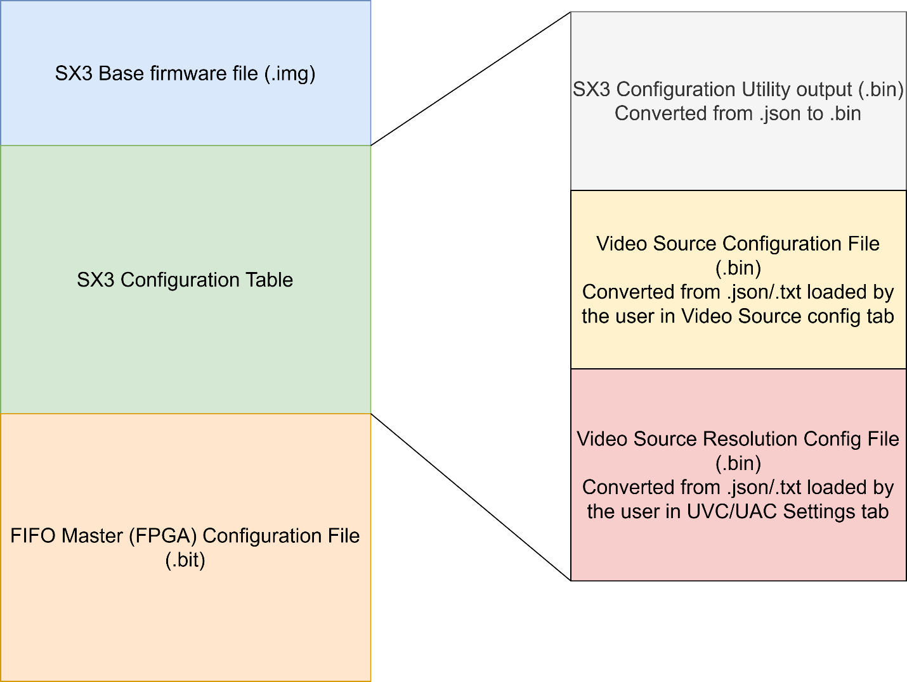

Figure 1: SX3 Merger Utility Output file

Merger Tool will have the following files as inputs:

1. SX3 Base firmware file (.img) :
   1. File will be provided by Cypress.
   2. Maximum size (256 KB)
2. FPGA Bit File (.bit) :
   1. User loads this file into the Configuration utility’s FIFO Master Tab
   2. This file should be appended to the end of SX3 Base firmware file
3. SX3 Configuration Table Raw Data File (.bin)
   1. Raw data output of the configuration utility inputs provided by the user.
   2. This file contains the following input files:
      1. Config utility data inputs : Raw data of the config utility inputs. This file is generated from the .json that the configuration utility generates while saving a configuration.
      2. Video source config file : This file is generated from the .json/.txt file input by the user in the Video source configuration tab
      3. Video resolution config file : This file is generated from the .json/.txt file input by the user in the UVC/UAC settings configuration tab

**<EOF>**